EC2 Web + RDBMS Setup with Dynatrace OneAgent & Metrics Analysis
Objective
This lab demonstrates how to:
- Create and configure an EC2 instance
- Install Dynatrace OneAgent
- Deploy a web application using LAMP stack (Apache, MySQL, PHP)
- Analyze logs and metrics via Dynatrace

Pre-requisites
- AWS account
- Dynatrace account (OneAgent install script access)
- Basic knowledge of Linux commands
- Security Group with ports: 22 (SSH), 80 (HTTP), 3306 (MySQL - optional for external access)

Step 1: Launch EC2 Instance
- Go to AWS Console → EC2 → Launch Instance
- Choose Amazon Linux 2 or Ubuntu 20.04 LTS
- Select t3.medium
- Configure Security Group:
  - SSH (22)
  - HTTP (80)
  - MySQL/Aurora (3306) – optional
Screenshot:
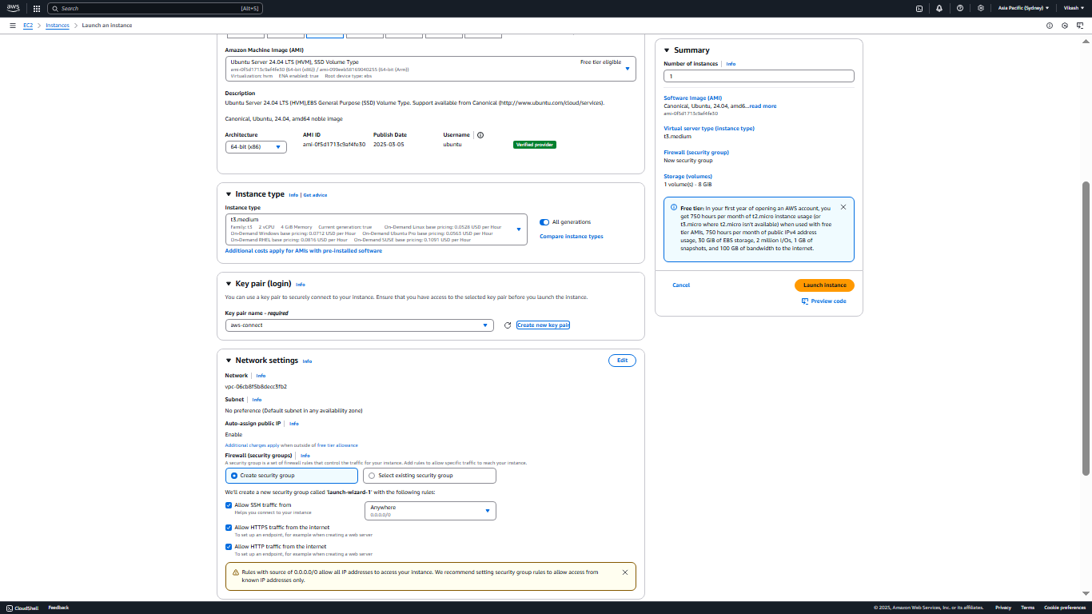
- Launch and connect via SSH:
ssh -i <your-key.pem> ec2-user@<EC2_PUBLIC_IP>
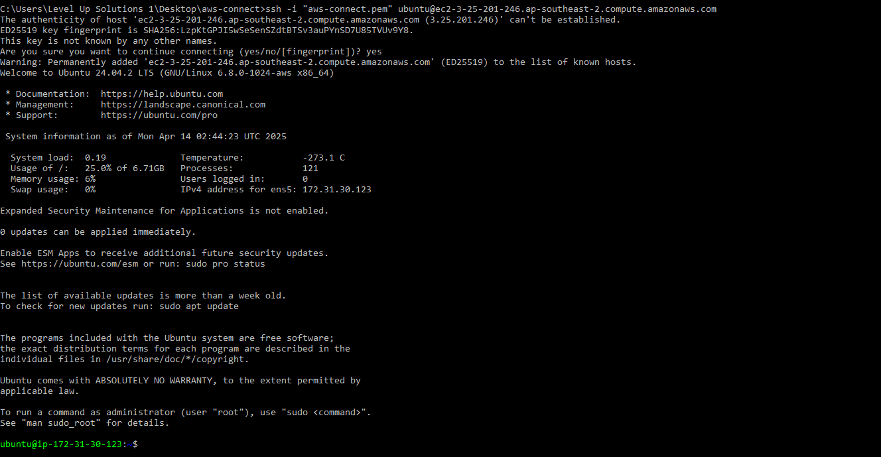

Step 2: Install Dynatrace OneAgent
- Download OneAgent install script from Dynatrace:
bash
wget -O Dynatrace-OneAgent.sh "https://<TENANT_ID>.live.dynatrace.com/api/v1/deployment/installer/agent/unix/default/latest?Api-Token=<TOKEN>&arch=x86&flavor=default"
- Run the installation:
bash
sudo /bin/sh Dynatrace-OneAgent.sh
Screenshot:
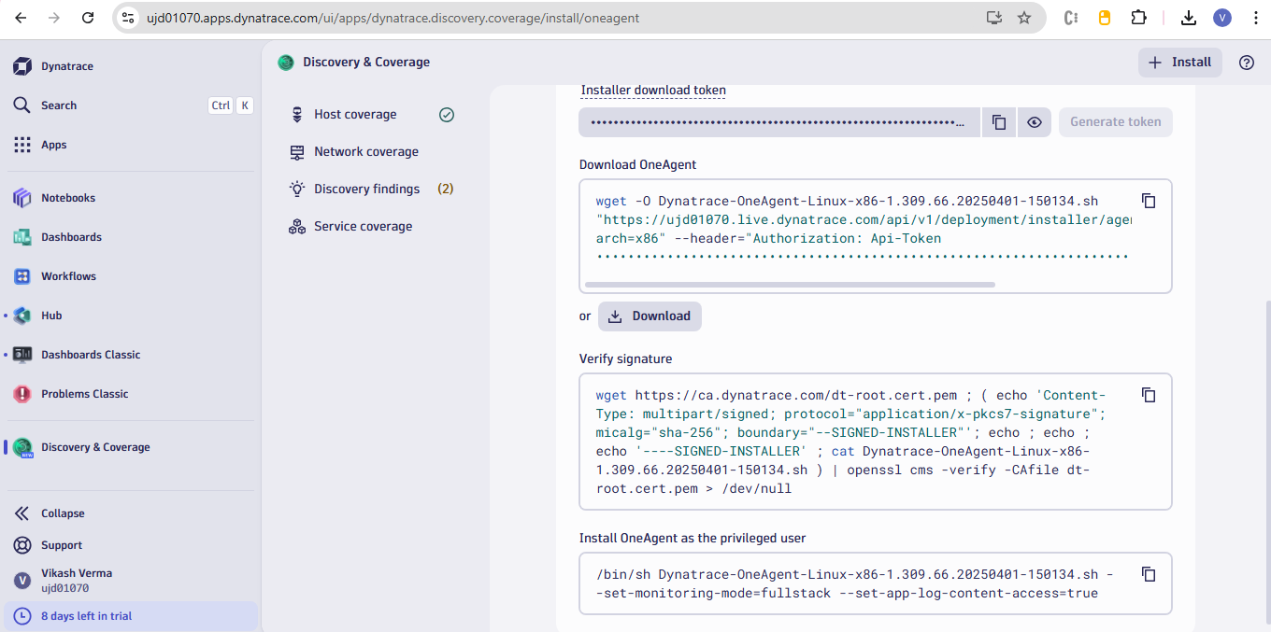

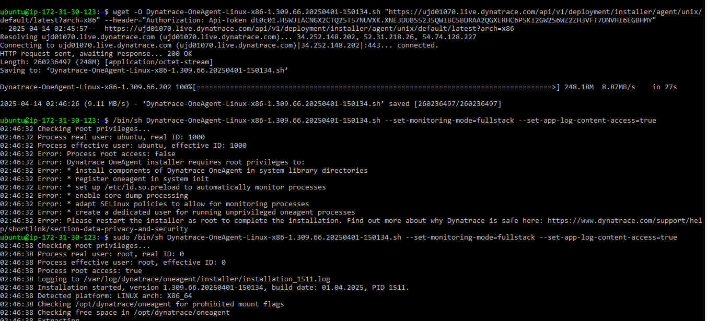
Step 3: Install Apache Web Server
On Amazon Linux:
bash
sudo yum update -y
sudo yum install httpd -y
sudo systemctl start httpd
sudo systemctl enable httpd
On Ubuntu:
bash
sudo apt update
sudo apt install apache2 -y
sudo systemctl start apache2
sudo systemctl enable apache2
sudo systemctl status apache2
Screenshot:
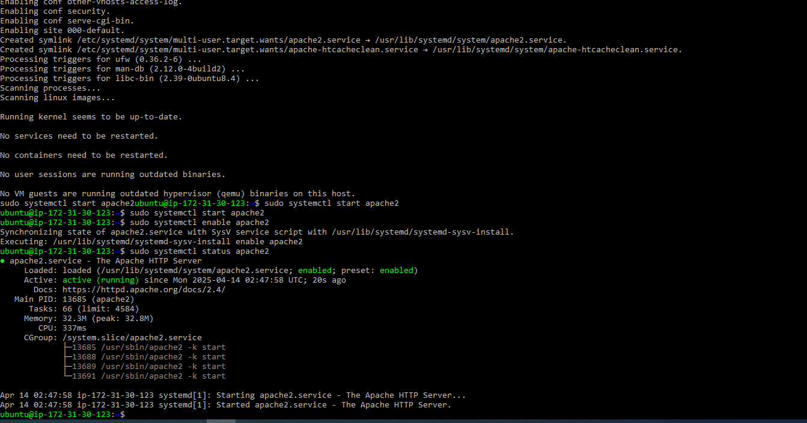
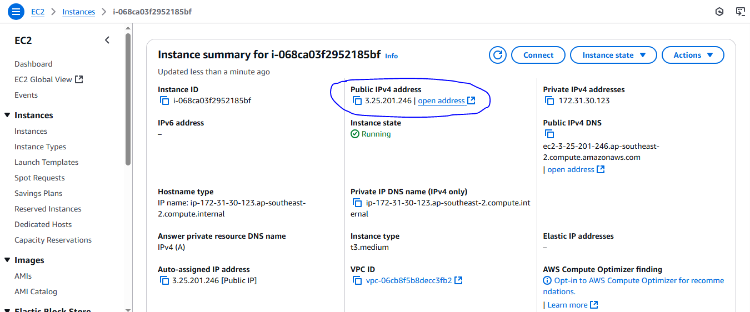
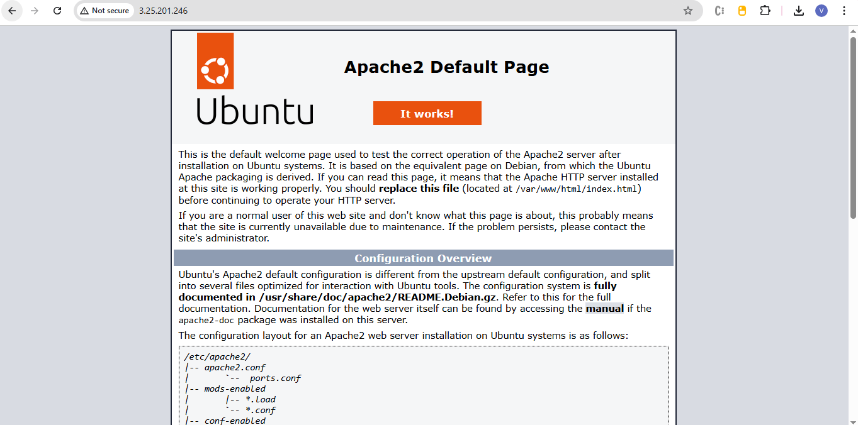

Step 4: Install PHP, MySQL, and Git
bash
sudo apt-get install apache2 php libapache2-mod-php php-mcrypt php-mysql php-curl php-xml php-memcached git mysql-server -y

Step 5: MySQL Configuration
Create DB and User
bash
sudo mysql
CREATE DATABASE simple_lamp;
CREATE USER 'username'@'localhost' IDENTIFIED BY 'password';
GRANT ALL PRIVILEGES ON simple_lamp.* TO 'username'@'localhost';
quit;
Screenshot:
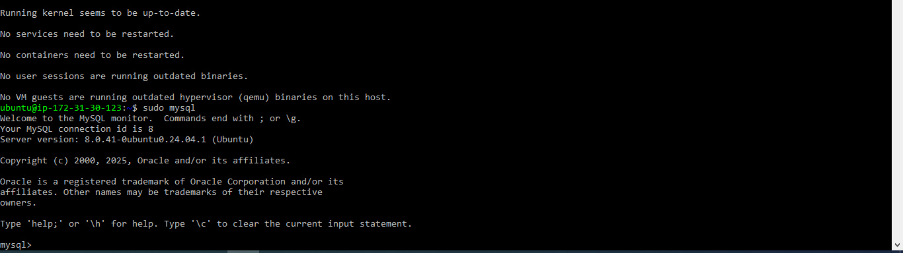
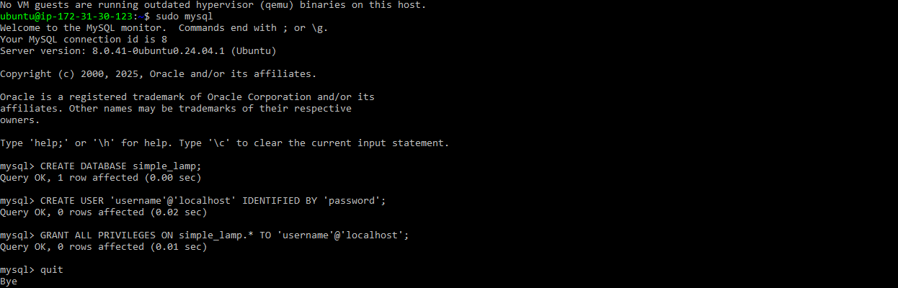

Step 6: Optional – Make MySQL Accessible Externally
Edit MySQL config:
bash
sudo vim /etc/mysql/mysql.conf.d/mysqld.cnf
press I to insert and then press esc and write :wq for save and exit
Change:
ini
bind-address = 0.0.0.0
Restart MySQL:
bash
sudo systemctl restart mysql
Screenshot:

Step 7: Clone and Deploy Web Application
bash
cd /var
sudo chown -R ubuntu:ubuntu www
cd /var/www/html
git clone https://github.com/qyjohn/simple-lamp
cd /var/www/html/simple-lamp
mysql -u username -p simple_lamp < simple_lamp.sql
sudo chown -R www-data:www-data uploads
Screenshot:
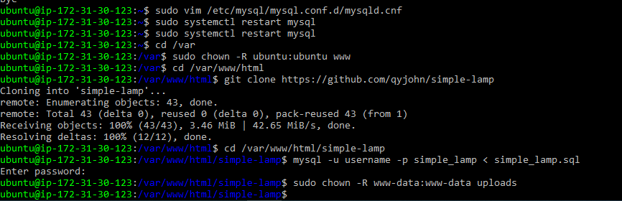

Step 8: Configure Web Application
Edit the config file:
bash
cd /var/www/html/simple-lamp
vim config.php
Update DB settings. Save with :wq.
Check the file:
bash

cat config.php

Step 9: Access Web Application
Open browser:
http://<EC2_PUBLIC_IP>/simple-lamp
Screenshot:
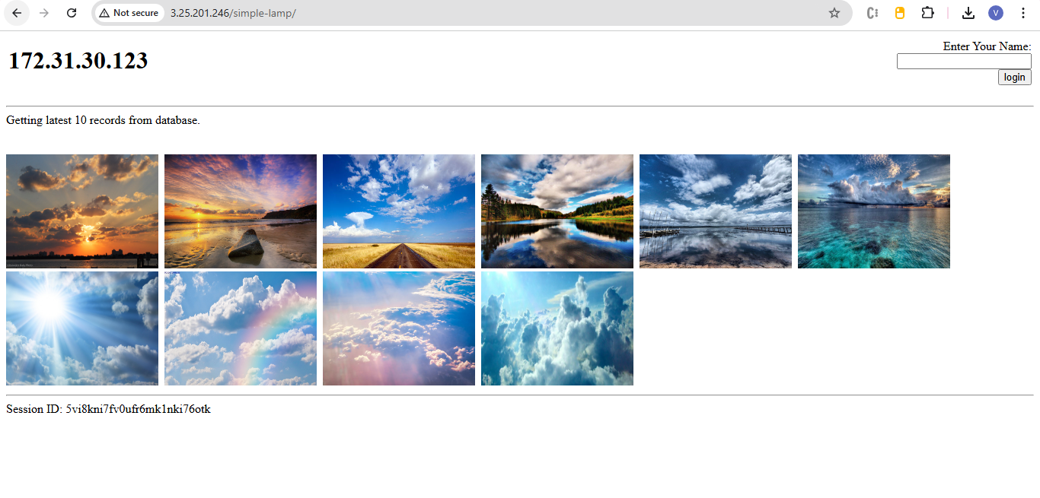

Step 10: View Metrics and Logs in Dynatrace
- Log into Dynatrace
- Navigate to Hosts → Select your EC2 instance
- Review:
  - Apache metrics (response time, request count)
  - PHP service metrics
  - MySQL metrics (queries/sec, slow queries)
  - Process logs (Apache error log, MySQL slow log)
Screenshot:
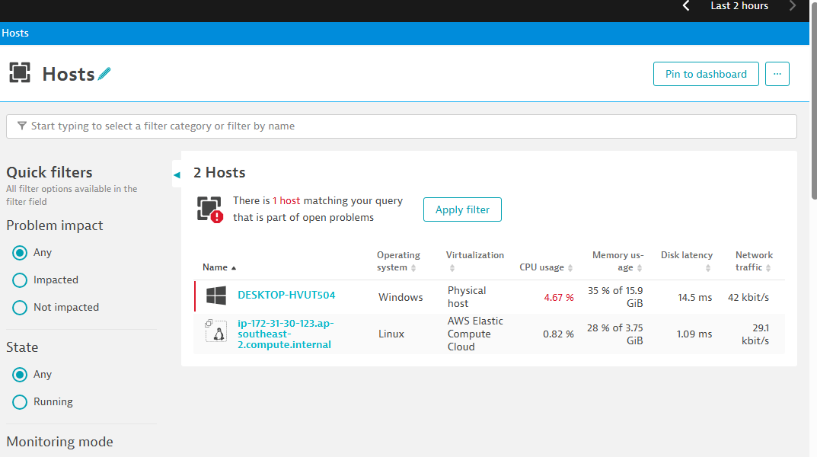

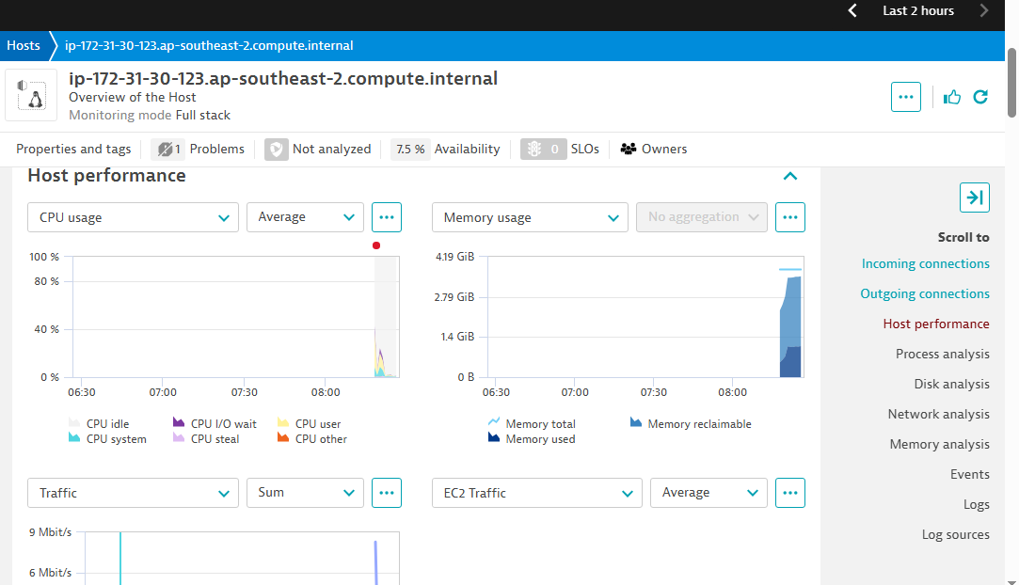

Optional: Reinstall MySQL
sudo apt-get remove --purge mysql-server
sudo apt-get autoremove
sudo apt-get autoclean
sudo apt-get install mysql-server
sudo mysql_secure_installation

